

FALL ARMYWORM UPDATE (adapted, with thanks from Seed and Grain Readiness and Response)
23rd December 2022
Key Points:
Approval for Insecticide use
The Insecticide Sparta^{R} (spinetoram 120g/L) is now on label for use on Fall Armyworm in maize and sweetcorn crops for ground applications.
Withholding periods
Maize:
Meat: DO NOT cut for feed, or graze animals intended for slaughter within 28 days after application.
Milk: DO NOT cut for feed, or graze lactating dairy animals producing milk for human consumption within 28 days after application.
Sweet corn:
Sweet corn stover can be grazed post-harvest.
Please contact your local advisor for details on the safe use of this insecticide.
Monitoring and field observations:
- There are now 29 positive FAW detections since 1 September 2022. The spread of detection now ranges from Kaitaia down to Whanganui.
- There are ongoing reports of FAW damage to crops, with some caterpillars found in the whorl.
- The models indicate that we can expect moths to be detected in larger numbers within the next week.
- There are over 200 traps across the growing regions of maize and sweetcorn, they include monitor sites from the previous season’s findings and others are spread wider to understand the movements of the pest across the country.
- Early detection and early control will prevent a rapid multiplication of the pest.
- Growers and reps should be actively scouting for caterpillars at the early stages of the crop, do not rely only on the moth catches from traps. As this is still an unwanted organism all findings must be reported to MPI: https://report.mpi.govt.nz/pest or using the app https://www.findapest.nz/ , by email to FAW@mpi.govt.nz or by freephone 0800 80 99 66.
- There are no negative consequences to growers for reporting, as this pest will not be controlled by removing crops.
- Cosmopolitan armyworm and Corn earworm (both present in NZ) have also been found in maize crops in Northland and Waikato in the past days, the differences can be seen on the identification cards provided by Plant and Food Research available on https://www.far.org.nz/assets/files/blog/files//8a209e4b-4ca8-5338-af06-f3b80bab18e2.pdf
- There have been reports of parasitic wasp activity on fall armyworm, it is too early to determine its impact, but this is encouraging when looking at developing IPM strategies.

Thresholds of economic damage
Plant Health Australia provides useful guidance for this:
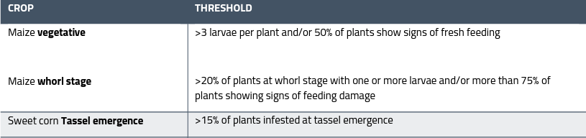
More detail on this on https://www.planthealthaustralia.com.au/wp-content/uploads/2020/11/Fall-Armworm-Quick-Guide.pdf
It is also of key importance to report any negative finds. If you are scouting your crops and not finding any FAW, it is valuable too. Send this in at faw@mpi.govt.nz .
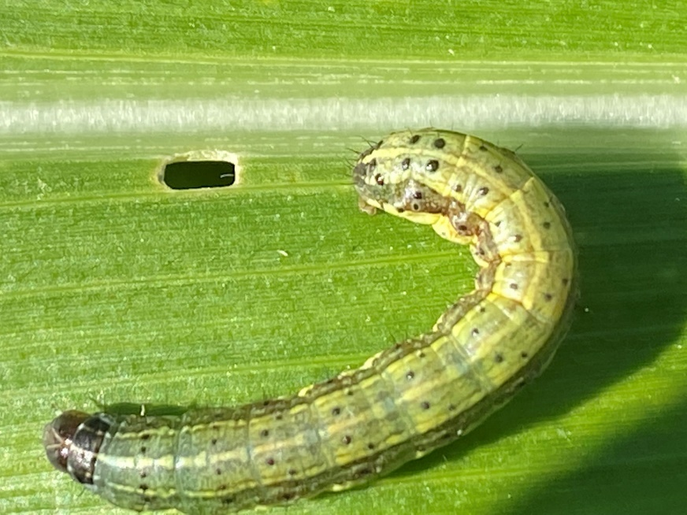
For useful tools and guides on detection and identification consult the VNZI website for the latest identification guides https://www.freshvegetables.co.nz/assets/Vegetables-NZ-Inc/Resources/Grower-resources/PFR_FAW-Factsheet_Oct-2022_reduced-file-size.pdf and MPI Website www.mpi.govt.nz/dmsdocument/50839-Fall-armyworm-fact-sheet or contact Antony Heywood Antony.heywood@hortnz.co.nz
A poster is available on the VNZI website here: https://www.freshvegetables.co.nz/assets/Vegetables-NZ-Inc/News-and-events/News/Fall-armyworm-poster-Hemisphere-crops-A3-crop-marks_Dec-2022.pdf

