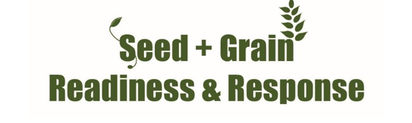
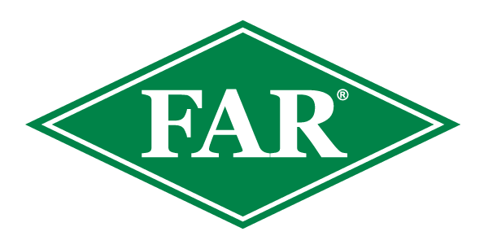

Fall armyworm update
22nd March 2024
Key points
FAW has been found in two Canterbury sweetcorn paddocks. In all, there have been 108 confirmed reports from Northland, Westland, Tasman, Bay of Plenty, Auckland, Waikato, Marlborough, and now Canterbury, in the 2023/24 growing season.
- Northland FAW populations are generally small, with some localised areas of higher damage. Consistent moth captures, although small in number, show the potential of growth rate variation within generations and possible fly-ins from other areas.
- Gisborne has recorded two FAW finds to date this season, there have been no reports from Hawkes Bay.
- In the South Island, FAW has recently been found in North Canterbury sweetcorn. An older find, in a similar location, has also been confirmed as FAW. There are multiple finds found on the West Coast, Tasman and Marlborough. Most larvae have pupated and these are starting to emerge. More moths have been caught and larvae are being reared for confirmation.
- Reports from Bay of Plenty, Auckland and Waikato are generally coastal, Suspect moths from Manawatū-Whanganui will be identified via DNA testing.
- Many susceptible crops around the country have been harvested (or are close to harvest) meaning a reduction in FAW’s preferred food source. This means it is important to scout neighbouring paddocks, as, in the absence of maize and sweetcorn, FAW will feed on a large variety of crops. Volunteer maize is another preferred FAW host.
- Parasitism of FAW by the parasitic wasp Cotesia spp, is being observed across the country along with assistance from other beneficials.
- Your observations are important. Please record them and inform us; without them, it is hard to validate and develop the modelling work we are doing.
- The insecticide Sparta® is on label for aerial and ground applications for controlling fall armyworm on maize and sweetcorn crops. Consult your advisor.
At this date last year there were 133 fall armyworm finds nationwide, including Northland, Auckland, Waikato and Taranaki.
If you are scouting crops please inform us; even if you do not find FAW, this population data is useful. The data provided to date has been fantastic. It will support FAW modelling and has been extremely helpful for ongoing work developing predictive tools and understanding FAW in New Zealand’s unique arable environments.

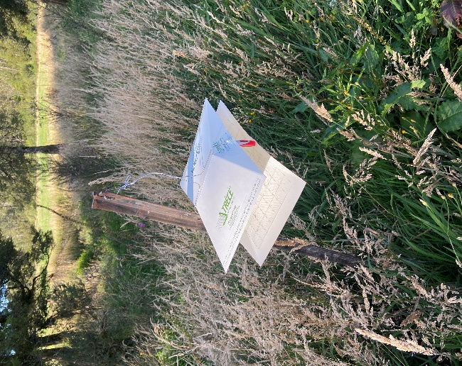
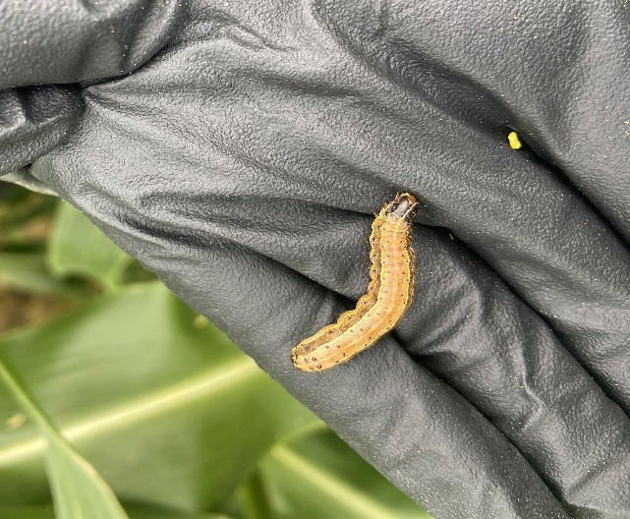

Fall armyworm in Canterbury
Although in populations are low, these larvae are significant in terms of the identification of seasonal distribution patterns.
FAW pheromone traps
Bucket and sticky traps like this one pictured are armed with a pheromone cap. This cap releases female FAW and attracts male moths. This season have consistently been catching moths in well serviced areas, if you are keen to monitor some traps please inform us.

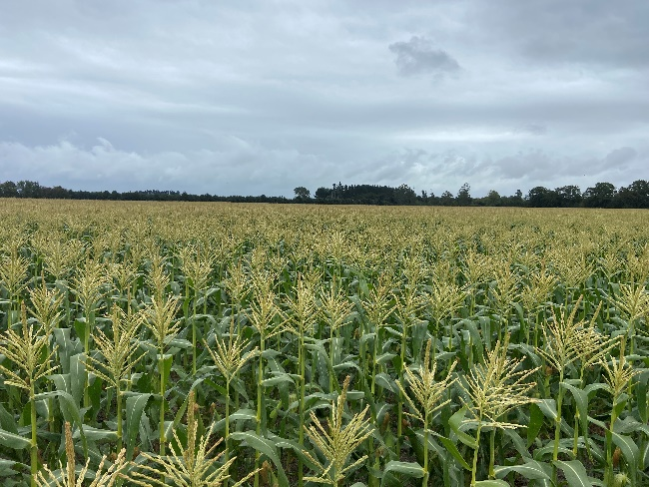
Sweetcorn and FAW
It doesn’t take much to make a sweetcorn cob non-viable for the market. Last season this grower lost up to 65% of cobs due to pest damage…greasy cutworm early on, some FAW but mainly corn earworm. Changing cultural practices has contributed to minimal damage this year. Pupa busting (post-harvest and before seeding), excellent weed control and crop monitoring have helped maximise productivity.

What to do if you think you find fall armyworm
Photograph it: FAW can be easily mistaken for other species, so if you suspect it, take a good quality photo, and be sure to include the head, body and rear of the larvae. This can be in multiple photos if necessary. This guide from the Queensland Department of Agriculture and Fisheries outlines how to take photos of FAW.
Catch it: Samples are important for positive identification and testing.
Contact us: Contact the Foundation for Arable Research at far@far.org.nz or Biosecurity Officer Ash Mills at ashley.mills@far.org.nz
Trap network and active scouting and reporting have been fantastic throughout the season and are much appreciated.
- All data recorded (even zero finds) are valuable for the validation of modelling platforms and for understanding the pest in New Zealand.
- If you are keen to monitor a trap and share scouting information please get in touch.
- Data and observations of parasitism as well as potential relationships with other pest species would also be welcomed.

Consult the FAR website for the latest resources and identification guides
FAR Research | Welcome to the Foundation for Arable Research
Listed below are useful updates, tools and guides on detection and identification
FAR Research | Fall armyworm identification and background
FAW larval identification guide (publications.qld.gov.au)
For advice around Sparta, FAW information and requesting a great FAW glovebox guide - Fall Armyworm (corteva.co.nz) and this FAW Sparta technote Salesforce

Thresholds for economic damage
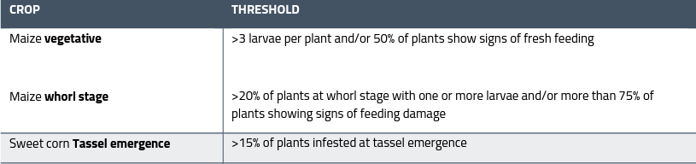
Plant Health Australia provides useful guidance for this:

Useful insight from over the ditch - https://www.planthealthaustralia.com.au/fall-armyworm/
SGRR Davis Scale Guide - 86d44eb4-7d19-5ce5-befe-4dd32eeca38c.pdf (far.org.nz)

A farm Biosecurity Register is a great way of reducing the risk of unwanted weeds, pests and diseases arriving on your doorstep. Do you have one? Find out more here FAR Research | Arable Biosecurity Risk Register

