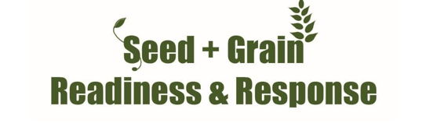


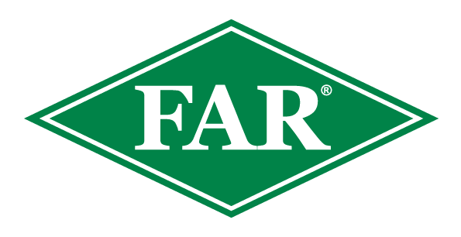

FALL ARMYWORM UPDATE
8th Dec 2023
Key Points:
FAW HAS BEEN IDENTIFIED IN NORTHLAND
- The 2023/24 growing season has 5 confirmed reports to date.
- First FAW moths of the season caught at two locations have now resulted in finds of early instar larvae in adjacent maize paddocks. Thus validating the use of pheromone traps, as an indicator and for data capture.
- There have been 2 new moth captures at different locations that require analysis for confirmation.
- As surveillance has increased, localised findings of Cosmopolitan armyworm, Greasy Cutworm and Tropical armyworm have been observed across the country.
- Very good observations of parasitised Cosmopolitan armyworms are encouraging as the wasp, Cotesia sp. will also attack FAW.
- Earlier planted crops are less likely to suffer significant economic loss as early-season FAW populations are yet to build up multi-generational numbers.
- Being observant at this early stage is important, the earlier FAW is identified the likelier effective management will be achieved.
- Observations are important, please record them and inform us.
- The insecticide Sparta® is on label for aerial and ground applications for controlling Fall Armyworm on maize and sweetcorn crops. Consult with your advisor and avoid the use of insecticides that are ineffective on Fall Armyworm and potentially harmful to beneficial insects such as parasitic wasp Cotesia sp. which will help contain the numbers.
- Refer to the Davis Scale of Economic Damage and consult with your agronomist when making decisions on Sparta application.
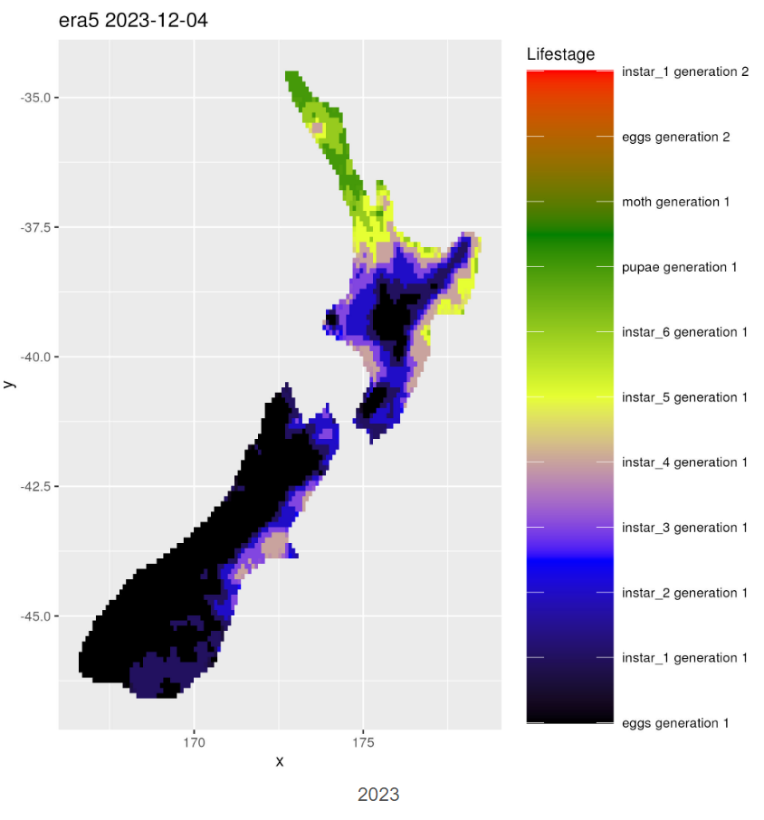

Modelling courtesy of Dr Nicholas Davies from AgResearch
Data collected as a direct result of trap monitoring and crop scouting allows Nick to validate and continually finetune his population status estimations. This and another model predicting winter survival, are eventually intended to give a robust tool to alert the industry as early as possible of the likelihood of FAW presence.

At this date last year there were 5 Fall armyworm finds nationwide, including Northland, Auckland and Waikato.
- There are no confirmed finds this season outside of Northland.
- Average temperatures were considerably lower in regions compared to winter and spring last year.
- Marginal areas may have seen FAW populations unable to overwinter and depend on migration from more favourable areas.
- If you are scouting your crops inform us even if you do not find FAW, THIS DATA IS USEFUL.

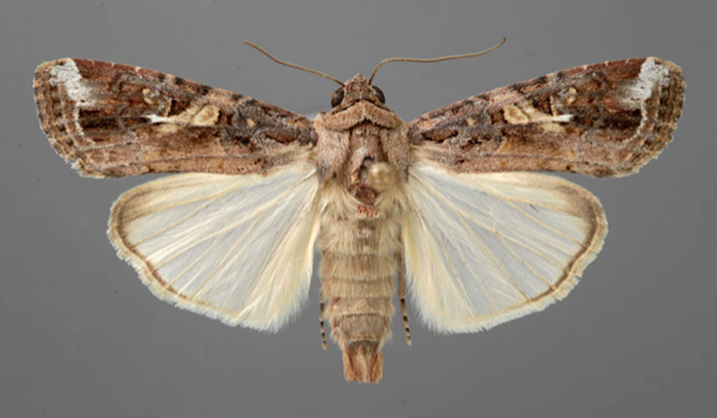
Photo: Fall armyworm Moth
FAW moths showing characteristic white underwings. They are delicate and easily damaged, any moths found in pheromone traps can be DNA tested.
https://assets.far.org.nz/Distinguishing-moths-in-Fall-Armyworm-FAW-traps.pdf
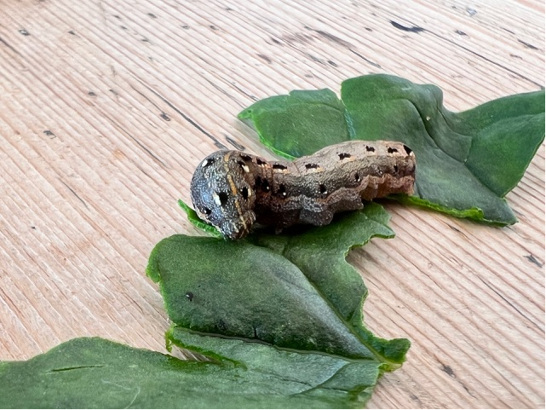
Photo of Tropical Armyworm nr Auckland courtesy of Deb Holdsworth.
Other species like this Tropical armyworm (Spodoptera litura) have been identified on various crops including maize and sweetcorn.
https://assets.far.org.nz/True-armyworm-Spodoptera-litura-Jan23.pdf

What to do if you think you find Fall Armyworm
Photograph it: It can be easily mistaken for other species, so if you suspect Fall armyworm, take a good quality photo, and be sure to include the head, body and rear of the larvae. This can be in multiple photos if necessary. This great guide from the Queensland Department of Agriculture and Fisheries will help How to take a photo of FAW_24Mar20 (thebeatsheet.com.au)
Catch it: Samples will be welcomed and are important for positive identification and testing.
Contact us: Contact the Foundation for Arable Research at FAR@far.or.nz or Biosecurity Officer Ash Mills at ashley.mills@far.org.nz
- Trap network and active scouting and reporting have been fantastic throughout the winter and spring and are much appreciated.
- All data recorded (even zero finds) are valuable for the validation of modelling platforms and for understanding the pest in New Zealand.
- If you are keen to monitor a trap and share scouting information please get in touch
- Data and observations of parasitism as well as potential relationships with other pest species would also be welcomed.
Consult the FAR website for the latest resources and identification guides
FAR Research | Welcome to the Foundation for Arable Research
Listed below are useful updates, tools and guides on detection and identification
FAR Research | Fall armyworm identification and background
For advice around Sparta, FAW information and requesting a great FAW glovebox guide - Fall Armyworm (corteva.co.nz)
Thresholds of economic damage
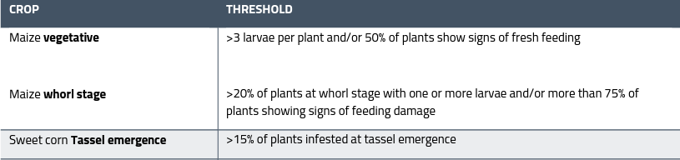
Plant Health Australia provides useful guidance for this:

Useful insight from over the ditch - https://www.planthealthaustralia.com.au/fall-armyworm/
SGRR Davis Scale Guide - 86d44eb4-7d19-5ce5-befe-4dd32eeca38c.pdf (far.org.nz)

