

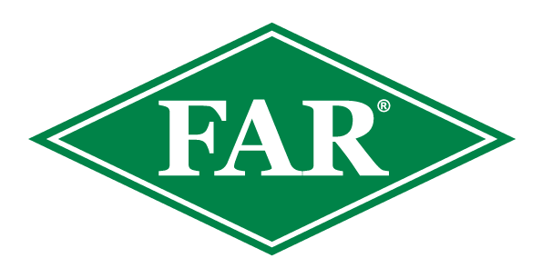

**FALL ARMYWORM UPDATE**

10th Nov 2023

**Key Points:**

* **The 2023/24 growing season has 0 confirmed reports to date.**
* **There was a total of 140 confirmed reports of FAW across NZ during the response period before the industry-led transition to long-term management began on Friday 21st April 2023.**
* **Trap monitoring and scouting in Northland and West Coast have shown no moths or obvious signs of FAW larvae.**
* **As Surveillance has increased, localised findings of Cosmopolitan armyworm, Greasy Cutworm and possible very early instar Tropical armyworm have been observed.**
* **Maize plantings have begun throughout the North Island, with some approximately 3 weeks old. Weather conditions have unfortunately held up growers in various areas. Earlier planted crops are less likely to suffer significant economic loss as early-season FAW populations are yet to build up multi-generational numbers.**
* **As temperatures increase, the life cycle will begin to speed up with any winter larvae that have survived pupating, and early moths laying egg masses. Being observant at this early stage is important, the earlier FAW is identified the likelier effective management will be achieved. Newly hatched neonates are 1.5mm in length, windowing on leaves showing their presence. As they grow to 1st instar larvae, they will disperse to surrounding host plants.**
* **Observations are important, please record them and inform us.**
* **The insecticide Sparta® is on label for aerial and ground applications for controlling Fall Armyworm on maize and sweetcorn crops. Consult with your advisor and avoid the use of insecticides that are ineffective on Fall Armyworm and potentially harmful to beneficial insects such as parasitic wasp *Cotesia sp.*****which will help contain the numbers.**

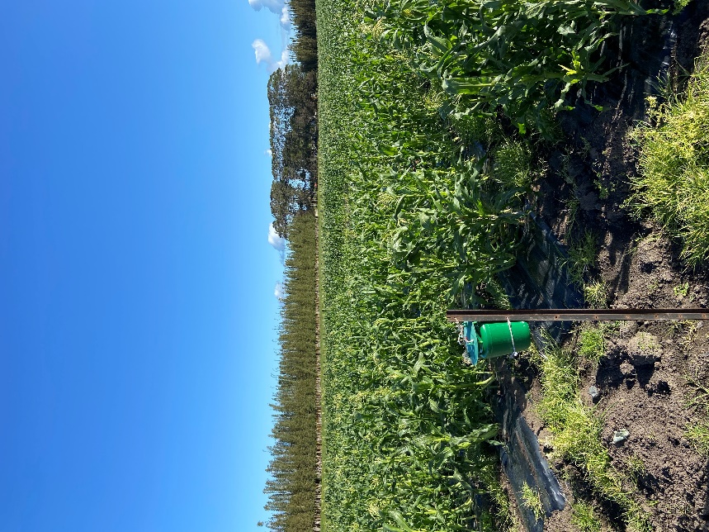

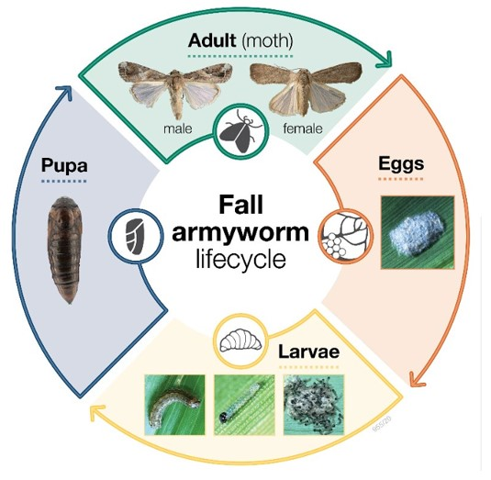Photo: A Northland Sweetcorn Crop with FAW Bucket trap. The trap was installed in the winter when this crop was planted under cloches. It is painted green to reduce bee capture which are attracted to the normally white and yellow traps in some areas.

Cosmopolitan armyworm found in a Northland Maize Crop. Damage showed as cutting around the edge of leaves with the larvae found in the centre of the plant. The Parasitic wasp spp known to parasitise FAW were originally released to control Cosmopolitan armyworms. Unless the crop is at risk, think about allowing larvae to be predated on by the wasp, building up its numbers for potential FAW outbreak.

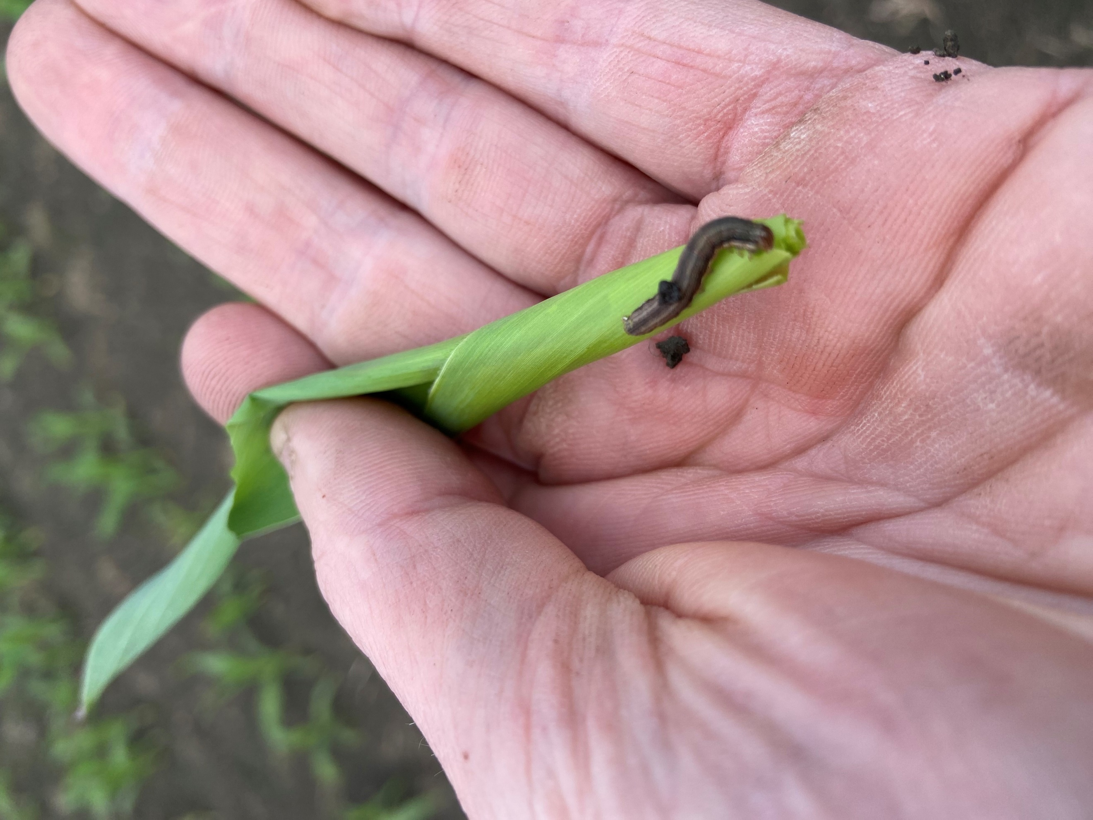

Some shotgun holes on young sweetcorn crops. Although this damage is consistent with FAW and some other noctuid pests, no larvae were found nearby, the farm manager has been informed and will identify the pest for appropriate management.

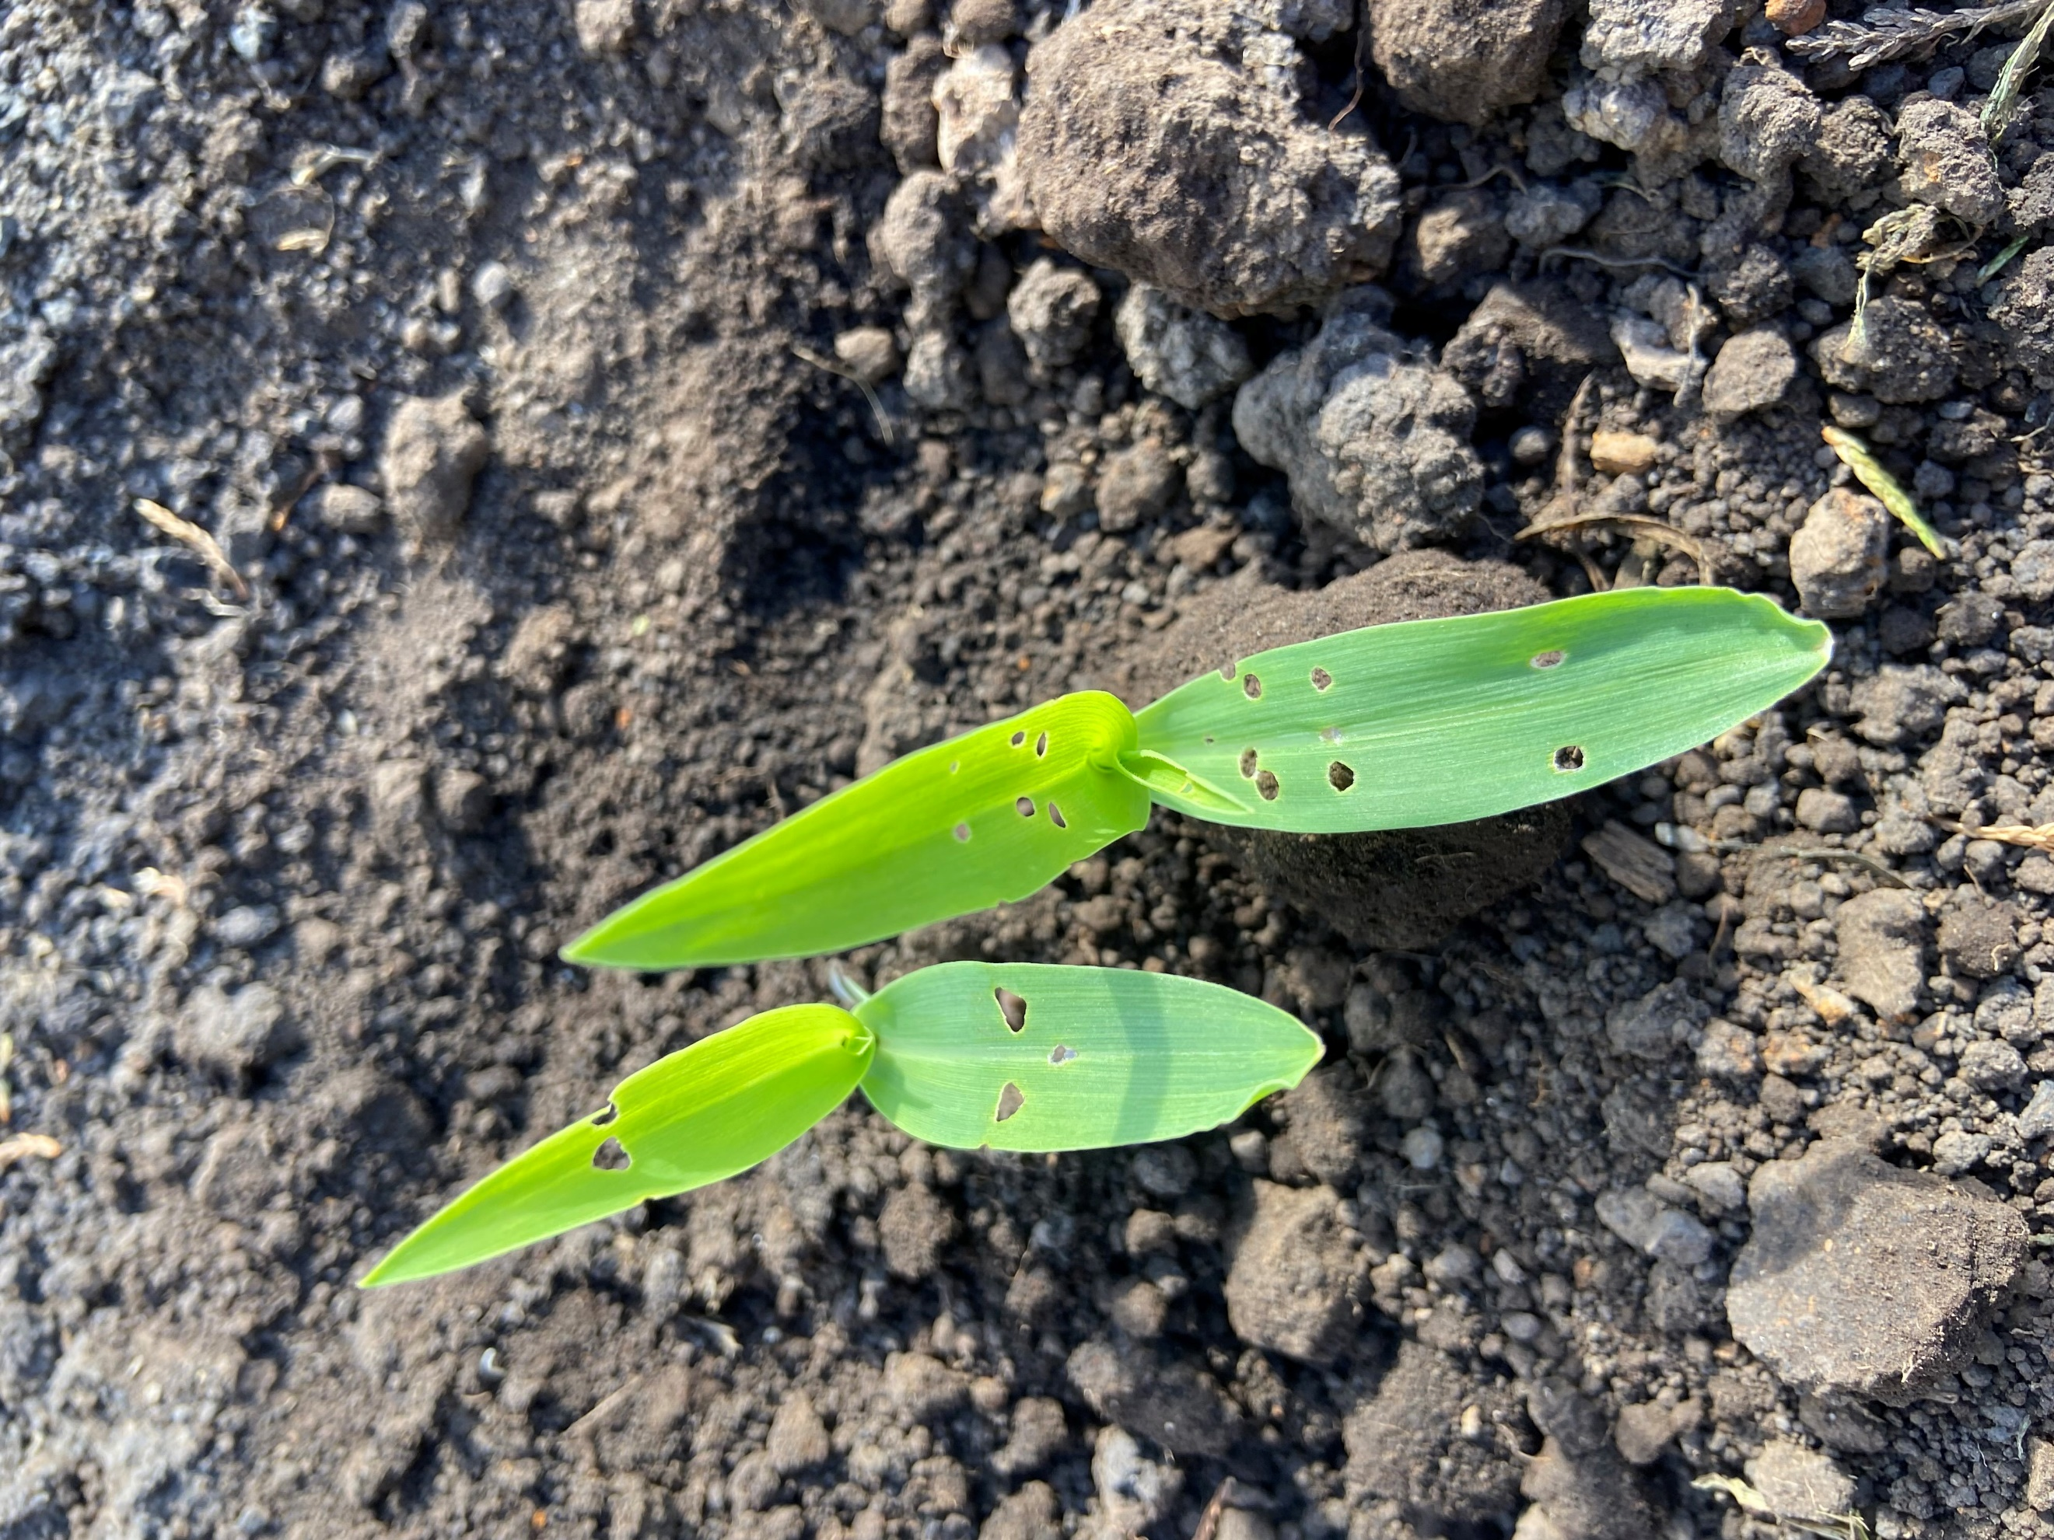

**What to do if you think you find Fall Armyworm**

**Photograph it:** It can be easily mistaken for other species, so if you suspect Fall armyworm, take a good quality photo, and be sure to include the head, body and rear of the larvae. This can be in multiple photos if necessary. This great guide from the Queensland Department of Agriculture and Fisheries will help [How to take a photo of FAW_24Mar20 (thebeatsheet.com.au)](https://thebeatsheet.com.au/wp-content/uploads/2020/04/CaterpillarIdentification-TakingPhotos-24March20.pdf)

**Catch it:** Samples will be welcomed and are important for positive identification and testing.

**Contact us:** Contact the Foundation for Arable Research at [FAR@far.or.nz](mailto:FAR@far.or.nz) or biosecurity officer Ash Mills at [ashley.mills@far.org.nz](mailto:ashley.mills@far.org.nz)

Consult the FAR website for the latest resources and identification guides

[FAR Research | Welcome to the Foundation for Arable Research](https://www.far.org.nz/search?q=fall+armyworm&sort=date)

Listed below are useful updates, tools and guides on detection and identification.

[FAR Research | Fall armyworm identification and background](https://www.far.org.nz/resources/fall-armyworm-identification-and-background)

[86d44eb4-7d19-5ce5-befe-4dd32eeca38c.pdf (far.org.nz)](https://assets.far.org.nz/blog/files/86d44eb4-7d19-5ce5-befe-4dd32eeca38c.pdf)

<https://www.planthealthaustralia.com.au/fall-armyworm/>

[Fall Armyworm (corteva.co.nz)](https://www.corteva.co.nz/News-and-Resources/faw.html)