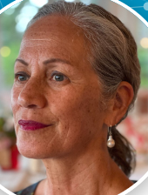 | Kay Read  General Manager, Regions | kay.read@mbie.govt.nz  029 200 6428
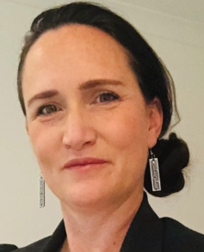 | Portia McKenzie  Director Regional Development (North) | portia.mckenzie@mbie.govt.nz  021 849 510
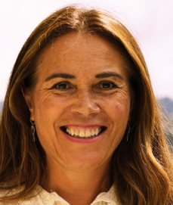 | Leah MacDonell  Director Regional Development (Central/South) | leah.macdonell@mbie.govt.nz  021 807 674
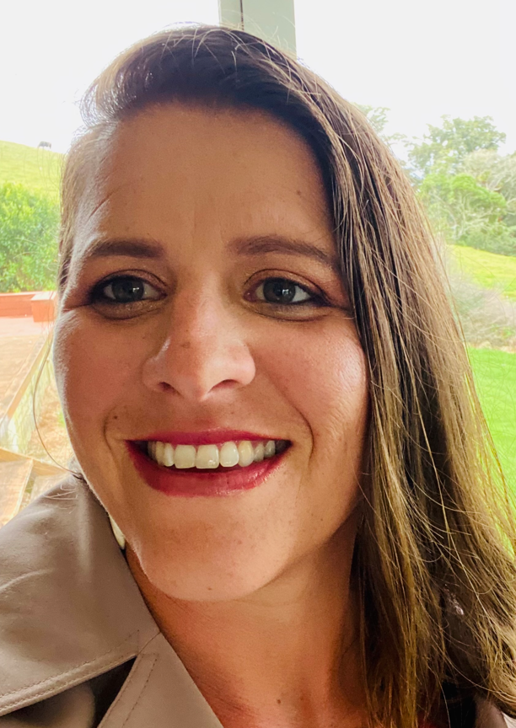 | Jo Littin  Principal Regional Advisor  Tai Tokerau | jo.littin@mbie.govt.nz  021 856 580
 | Kowhai Dalton  Principal Regional Advisor  Tai Tokerau | kowhai.dalton@mbie.govt.nz  021 807 373
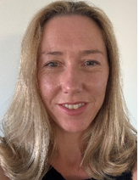 | Shannon Williams  Principal Regional Advisor  Tairawhiti | shannon.williams@mbie.govt.nz  021 838 231
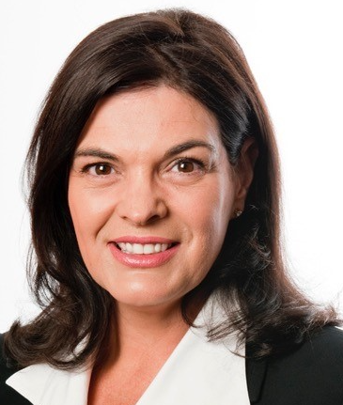 | Michelle Templer  Principal Regional Advisor  Waikato | Michelle.templer@mbie.govt.nz  021 828 596
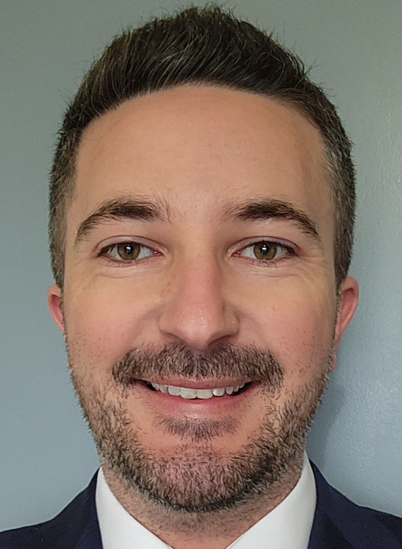 | Rob Hoy  Senior Regional Advisor  Waikato | Rob.hoy@mbie.govt.nz  021 835 936
 | Christina Diamond  Principal Regional Advisor  Bay of Plenty | christina.diamond@mbie.govt.nz  021 827 058
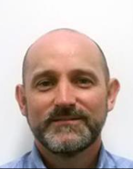 | Cameron Osmond  Principal Regional Advisor  Hawkes Bay | cameron.osmond@mbie.govt.nz  021 894 043
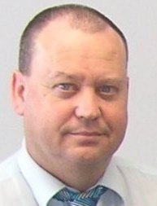 | Terence Curran  Principal Regional Advisor  Manawatu / Whanganui / Kapiti/Tararua | terry.curran@mbie.govt.nz  029 249 5341
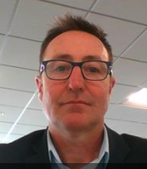 | Shane Wratt  Principal Regional Advisor  Wairarapa | shane.wratt@mbie.govt.nz  021 835 275
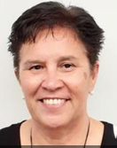 | Carol Ngawati  Senior Regional Advisor  Key contact for Bay of Plenty | carol.ngawati@mbie.govt.nz  021 898 736
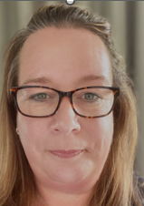 | Jo Verry  Acting Programme Director SWEP  Key contact for Auckland | jo.verry@mbie.govt.nz  021 826 737`
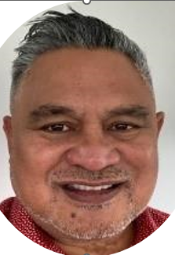 | William Ulugia  Manager North  Key contact for Auckland | william.ulugia@mbie.govt.nz  021 831 941

