


FALL ARMYWORM UPDATE (Courtesy of Seed and Grain Readiness and Response)
13^{h} January 2023
Key Points:
- South Island Fall armyworm presence confirmed on the West Coast.
- 56 confirmed finds of FAW this season nationwide.
- The insecticide Sparta has been approved for use on maize and sweetcorn crops.
- We are still in a response. All finds must be reported to MPI.
New finds:
South Island: There have now been confirmed finds of Fall Armyworm on the West Coast. Early this week the find was confirmed in a paddock of maize near Hokitika, there are other finds in the region now to suggest several maize crops are affected. Members of the FAR/SGRR team along with Dr Scott Hardwick from AgResearch/B3 visited the property on Thursday 12th January to assess damage and the efficacy of control. SGRR highlighted the swift reporting by the grower and the local rep and the importance of doing this to raise the alert.
See photos below for visible damage in whorl and accumulation of frass (caterpillar faeces). The maize plants are at the 8-10 leaf stage and the larvae present were large (instars 4-5), indicating that some had already dropped to begin pupation. Growers need to be inspecting leaf for early signs of damage before the larvae is inside the whorl, this will enable more effective control.
Well over 25% of plants were affected at the whorl stage, so the decision to spray was the correct one, based on the threshold guide from international data.
There was also presence of Corn Earworm (Helicoverpa armigera) in the crop. If you have doubts given the similarities, photograph different specimens and send multiple pictures in to MPI.
Over 200 FAW traps deployed by the response group continue to be assessed throughout New Zealand.
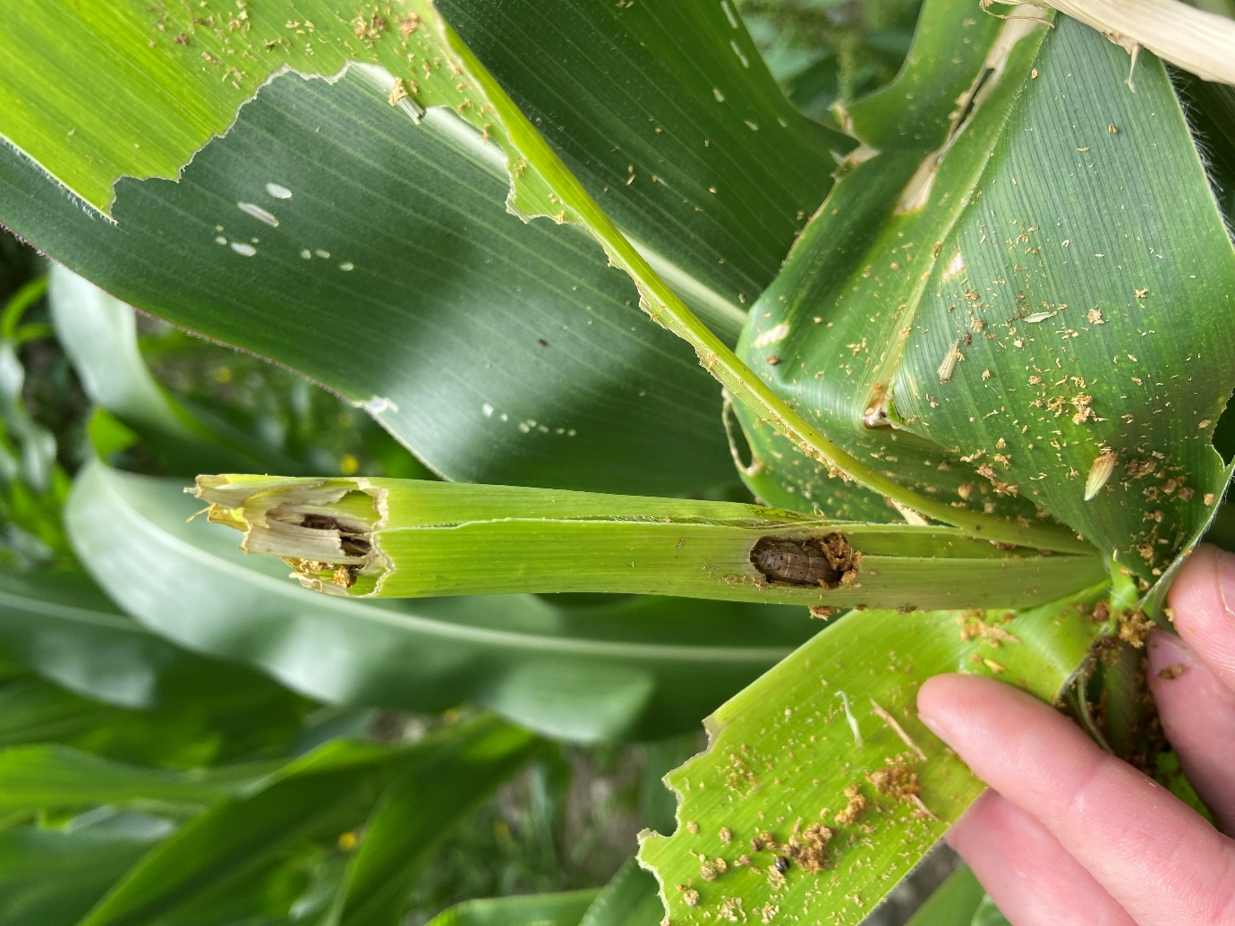
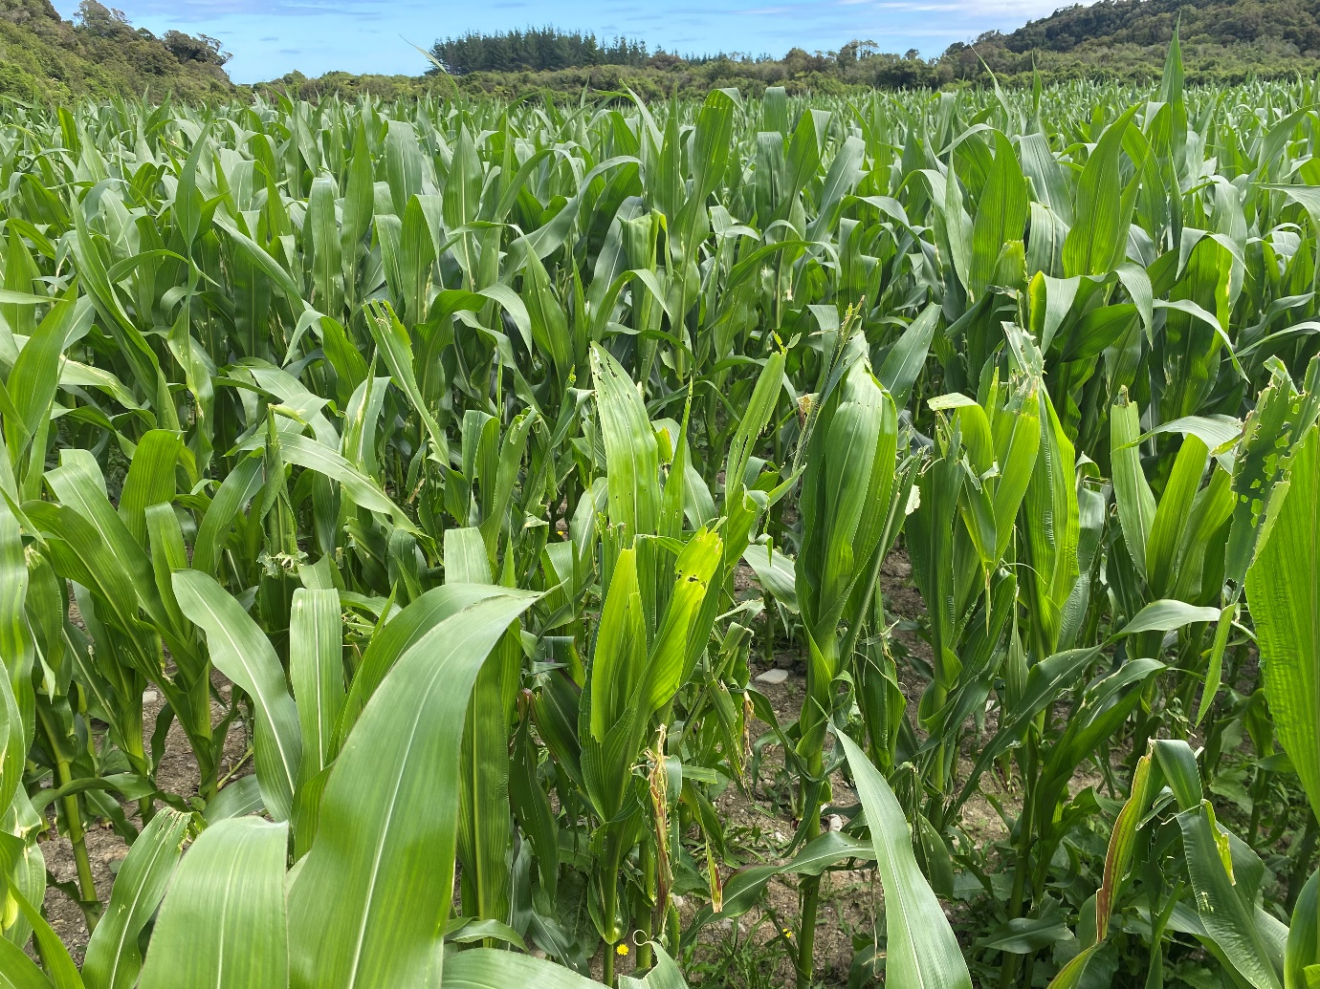
National FAW official data: as at Friday 13th January, MPI has received 117 enquiries since 1st September 2022 with 56 confirmed positives (up 11 from last week) – three of these finds were on the West Coast of the South Island.
The Insecticide Sparta (spinetoram 120g/L) is now on label for use on Fall Armyworm in maize and sweetcorn crops for ground applications.
Withholding periods
Sweet corn: 14 days
Sweet corn stover can be grazed post-harvest.
Tomatoes: 7 days
Vegetable Brassicas: 3 days
Maize:
Meat: DO NOT cut for feed, or graze animals intended for slaughter within 28 days after application.
Milk: DO NOT cut for feed, or graze lactating dairy animals producing milk for human consumption within 28 days after application.
Please contact your local advisor for details on the safe use of this insecticide.
Monitoring and field observations:
- The models indicate that we can expect detections of moths during this week and the next – please continue to check traps and report online.
- Growers and reps should be actively scouting for caterpillars on the crop, do not rely only on the moth catches from traps. As this is still an unwanted organism all findings must be reported to MPI: https://report.mpi.govt.nz/pest or using the app https://www.fi ndapest.nz/ , by email to FAW@mpi.govt.nz or by freephone 0800 80 99 66.
- There are no negative consequences to growers for reporting, as this pest will not be controlled by removing crops.
Thresholds of economic damage
Plant Health Australia provides useful guidance for this:
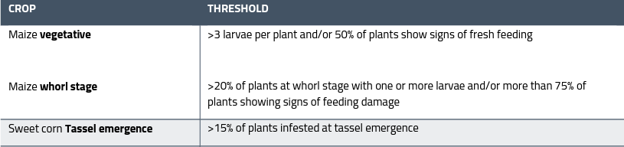
For useful tools and guides on detection and identification consult the PVNZ website for the latest identification guides https://www.processvegetables.co.nz/assets/Uploads/PFR-FAW-Factsheet-Oct-2022-reduced-file-size.pdf and MPI Website www.mpi.govt.nz/dmsdocument/50839-Fall-armyworm-fact-sheet or contact Richard Palmer Richard.Palmer@hortnz.co.nz
A poster is available on the PVNZ website here: https://www.processvegetables.co.nz/assets/Uploads/Fall-armyworm-poster-Hemisphere-crops-A3-crop-marks-Dec-2022.pdf

