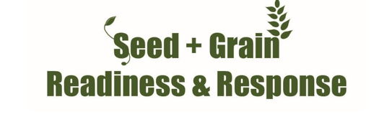

FALL ARMYWORM UPDATE
20^{h} January 2023
Key Points:
- South Island Fall armyworm workshops on 24th ,25th January. Consult FAR website for details. www.far.org.nz/events
- Fall armyworm presence confirmed on the West Coast last week.
- ALL South Island maize and sweet corn crops should be scouted as well as ongoing surveillance in North Island,
- 76 confirmed finds of FAW this season nationwide – 20 since last week.
- The insecticide Sparta has been approved for use on maize and sweetcorn crops.
- We are still in a response. All finds must be reported to https://report.mpi.govt.nz/pest or 0800 80 99 66
National FAW official data: as at Friday 13th January, MPI has confirmed 76 finds since 1 September 2022 (up 20 from last week). Most of these have been larvae feeding in the crops.
South Island: There have now been three confirmed finds of Fall Armyworm on the West Coast.
See photos below from last week for visible damage in whorl and accumulation of frass (caterpillar faeces). The maize plants were at the 8-10 leaf stage and the larvae present were large (instars 4-5), indicating that some had already dropped to begin pupation. Growers need to be inspecting leaf for early signs of damage before the larvae is inside the whorl, this will enable more effective control.
FAW is now probably in other regions of the South Island and crops should be actively monitored.
Over 200 FAW traps deployed by the response group continue to be assessed throughout New Zealand, although the numbers of moths trapped continue to be very low.
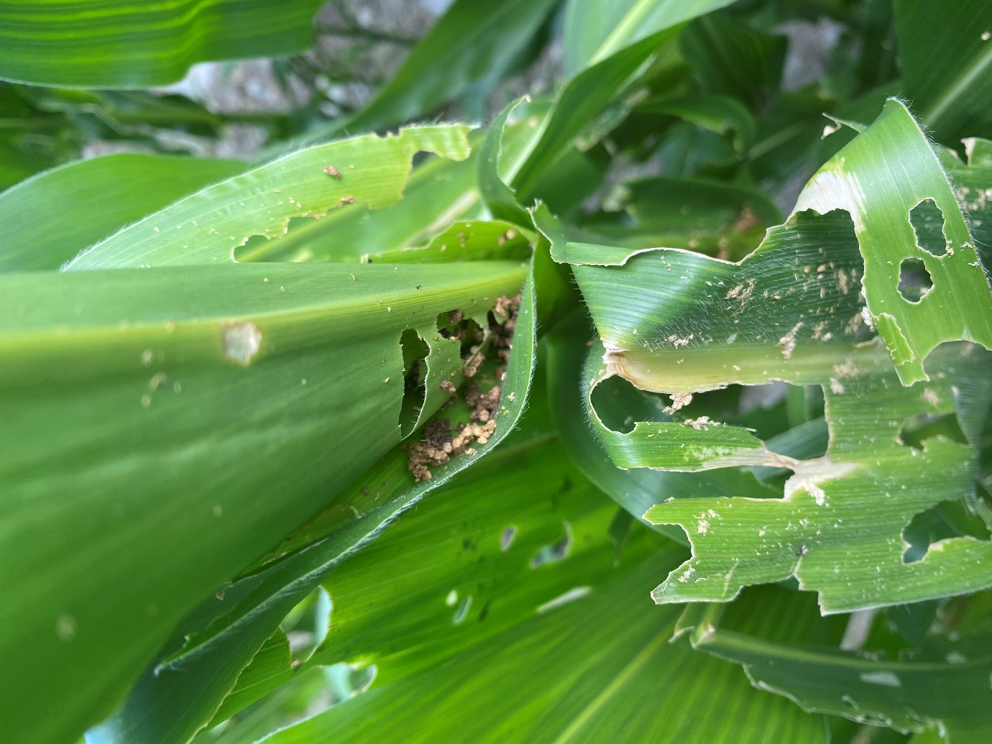

The Insecticide Sparta (spinetoram 120g/L) is now on label for use on Fall Armyworm in maize and sweetcorn crops for ground applications.
Please contact your local advisor for details on the safe use of this or any other insecticides on maize or sweetcorn.
Monitoring and field observations:
- Growers and reps should be actively scouting for caterpillars on the crop, do not rely only on the moth catches from traps. As this is still an unwanted organism all findings must be reported to MPI: https://report.mpi.govt.nz/pest or using the app https://www.fi ndapest.nz/ , by email to FAW@mpi.govt.nz or by freephone 0800 80 99 66.
- There are no negative consequences to growers for reporting, as this pest will not be controlled by removing crops.
Thresholds of economic damage
Plant Health Australia provides useful guidance for this:
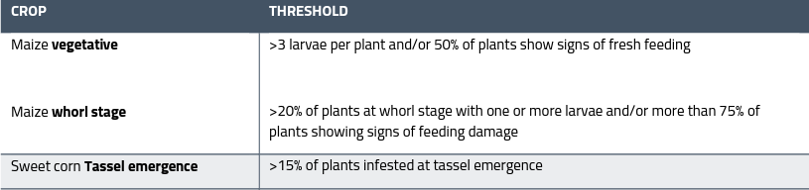
For useful tools and guides on detection and identification consult FAR website for the latest identification guides https://www.far.org.nz/assets/files/blog/files//8a209e4b-4ca8-5338-af06-f3b80bab18e2.pdf and MPI Website www.mpi.govt.nz/dmsdocument/50839-Fall-armyworm-fact-sheet or contact Ivan Lawrie ivan.lawrie@far.org.nz

