

**Fall armyworm update**

Thursday 17th April, 2025

# Key points

**Current status:** Fall armyworm (FAW) populations continue to be detected across New Zealand. However, with the exception of later planted maize and sweetcorn crops, the overall risk from FAW this season has likely passed. Most early and mid-season crops have either been harvested or have progressed beyond the growth stages most susceptible to damage. Adult moths are still being captured in pheromone traps, indicating continued presence in the environment. In the absence of preferred host plants such as maize and sweetcorn, it is important to remain vigilant by scouting C4 grasses and other potential host crops, as FAW may shift its feeding behaviour to alternative hosts.

**Preferred crops**: Now that preferred host plants such as maize and sweetcorn are largely absent from the landscape, adult FAW may seek alternative hosts. They are polyphagous, known to feed on over 350 plant species. However, they are most likely to favour other C4 grasses if available. Remain observant and report any suspected FAW activity.

**Crop monitoring**: Scouting for and managing volunteer maize and sweetcorn is critical. Observations of FAW infestations on volunteer plants have already been reported from several regions around the country. These volunteers can serve as important green bridges for sustaining FAW populations through the off-season

**Identify your pests**: For assistance in identifying FAW larvae and damage, contact FAR, refer to resources on the FAR website, or reach out to an agronomist.

**Cultural controls:** In regions where soil type and farm systems allow, paddock management practices such as light cultivation to approximately 10 cm depth, or the use of livestock to graze crop residues, can help destroy FAW and other noctuid pupae in the soil. This practice, sometimes referred to as “pupa busting,” may reduce local pest pressure in future seasons. Cultivation can also help manage **volunteer host plants** that may otherwise support pest populations in the off-season.

**Natural controls**: Widespread and encouraging observations of beneficial parasitoids, particularly *Cotesia ruficrus*, suggest natural controls may be effectively managing small FAW populations. Some growers believe these beneficial insects are significantly reducing FAW numbers.

**Other maize pests**: *Helicoverpa armigera* (corn earworm) and *Mythimna separata* (cosmopolitan armyworm) are present across the country. These species should be correctly identified to avoid unnecessary interventions.

**Communication**: Collaboration and information sharing among growers, agronomists, and industry experts are essential to refining management strategies and improving outcomes.

# Regional overview for 2024/25 season

## Northland

Moth catches continue to be observed, growers are encouraged to report any observations of FAW in the absence of maize and start checking any volunteer plants.

## Auckland and Waikato

FAW populations remain low, with no significant threat to maize crops. Sweetcorn growers should continue regular scouting. FAW larvae have been found in maize and sweetcorn volunteer plants, a reminder to remain vigilant.

## Bay of Plenty, Gisborne and Hawkes bay

FAW populations are present, but at low levels. Any maize left crops are nearing harvest and are unlikely to be negatively affected. Sweetcorn growers must remain vigilant and consult local agronomists if needed. FAW larvae have been found recently by Fruitfed Technical staff in Hawkes Bay sweetcorn volunteer plants, again a reminder to remain vigilant.

**Taranaki and Manawatu-Whanganui**

FAW found in maize and sweetcorn crops this season are likely to be seeking new host plants now that most maize and sweetcorn is harvested. Please be observant and report anything to us or your local advisor. Last autumn and winter, FAW was observed on residential lawns on multiple occasions in these regions.

## South Island (Tasman, Marlborough, Westland)

The last 10 days have seen the majority of maize paddocks harvested. This season's monitor paddocks in Westland saw populations of FAW in the cob and pupa in the ground at the point of harvest. Grazing the paddock and if possible, cultivation, could see the bulk of the population in paddocks destroyed. Moth flights are anticipated to start in the next 10 days by any surviving FAW. Please keep being observant.

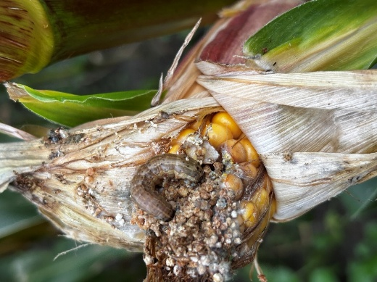

**Right** FAW larvae found **within a maize cob shortly before harvest.**

While most larvae will be destroyed during harvest, some may fall to the ground and survive. Pupae were also observed in the soil beneath this crop. The grower plans to graze cattle for 36 hours post-harvest, followed by immediate light cultivation. This cultural control approach may help reduce surviving FAW pupa and could also impact other noctuid pests such as Helicoverpa armigera, Wiseana (porina), and greasy cutworm prior to sowing a cover crop.

### Supporting beneficial insects

Preserving natural enemies of FAW is crucial. Encouraging native vegetation around fields can offer refuge for beneficial insects. Resources and guides on enhancing farm biodiversity are available on the FAR website [https://www.far.org.nz/resources/far-focus-13-biodiversity.](https://www.far.org.nz/resources/far-focus-13-biodiversity)

### Minimise insecticide use

Overuse of chemicals can disrupt beneficial insects such as parasitoid wasps *Cotesia ruficrus* and generalist predators like spiders, which help manage egg and early larval stages of FAW. Consult with advisors on how to balance pest control while protecting beneficials.

**Table 1** Economic thresholds for FAW damage in maize and sweet corn courtesy of AgResearch.

|  |  |  |
| --- | --- | --- |
| **Current recommendations** | |  |
|  | **Crop growth stage** | **Threshold** |
| **Maize** | Seedling  Early whorl (knee high)  Late whorl (shoulder high)  Tasselling - early silking | ≥5 % of plants are cut  ≥20 % of plants are infested  ≥40 % of plants are damaged and larvae are present  ≥20 % of plants are infested |
| **Sweetcorn** | Seedling  Early whorl (knee high)  Late whorl (shoulder high)  Tasselling - early silking | ≥5 % of plants are cut  ≥20 % of plants are infested  ≥40 % of plants are damaged and larvae are present  ≥5 % of plants are infested |

In previous seasons we have seen many cases of FAW surviving the application of insecticides not recommended for FAW control. In maize and sweetcorn, Corteva’s Sparta™ is on label for use against FAW. This product is also effective on other pest species.

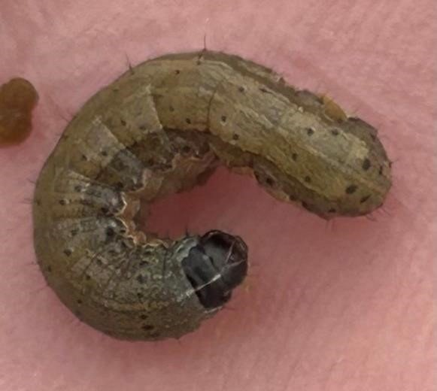

**Left** Late instar FAW showing the three key identifiers: a distinct ‘Y’ on the head leading into the dorsal line, four trapezoid patterned dots on the body segments and four pronounced dots in a square pattern at the rear.

Other pests may share a similar identification **but not all three key markings** together.

# Supporting the FAW SFFF project

On 27 March 2025, New Zealand and Australian researchers and industry experts convened to discuss ongoing challenges and collaborative research efforts on FAW management. Participants highlighted successes in biocontrol, particularly the effectiveness of *Cotesia spp* in New Zealand and the previous rediscovery of *Telanomus remus* parasitoids in Australia. Host plants were discussed and it was agreed that C4 grasses were likely the main hosts, and also likely overwintering hosts in NZ. Issues raised included concerns over the impacts of broad-spectrum insecticides on beneficial insects and ongoing research into atmospheric modelling for understanding FAW migration patterns between Australia and New Zealand. Experts emphasised the need for improved IPM strategies and selective insecticide use to protect beneficial parasitoid populations.

# What to do if you find FAW

1. **Photograph:** Take clear photos of the head, body, and rear.
2. **Catch:** Samples are crucial for positive identification and DNA testing.
3. **Trap:** If you would like to monitor a trap, or have FAW in your crop please reach out.
4. **Contact:** Contact FAR@far.org.nz or Biosecurity Officer Ash Mills at ashley.mills@far.org.nz.

## Useful links

FAW identification, guides and relevant fact sheets:

[https://www.far.org.nz/resources/fallarmyworm-identification-and-background](https://www.far.org.nz/resources/fall-armyworm-identification-and-background)

