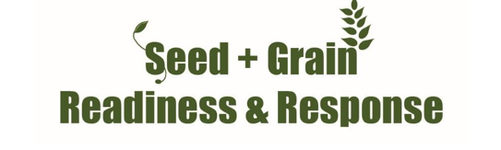
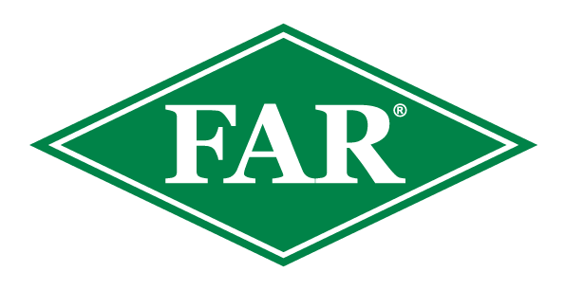

Fall armyworm update
19th^{th} April 2024
Key points
Since the last update on the 5th April 2024, there has been one new confirmed find. In the 2023/24 growing season, there have been 111 confirmed reports from Northland, Westland, Tasman, Bay of Plenty, Auckland, Waikato, Marlborough, and Canterbury.

- Northland FAW moth flights are still being observed in pheromone traps consistently, with a large moth flight being recorded this week. Maize grain remains to be harvested in multiple locations with varying reports of cob/kernel damage.
- Gisborne has recorded two FAW finds to date this season, there have been no reports from Hawkes Bay.
- In the South Island there have been multiple finds found on the West Coast, Tasman, Marlborough and Canterbury this season. Most silage crops have been harvested with grain harvests still to come. A significant rain event may have disrupted the pupation and early instar stages of some localised populations.
- Reports from Bay of Plenty, Auckland and Waikato are generally coastal, again most if not all silage crops have been harvested.
- Many susceptible crops around the country have been harvested (or are close to harvest) meaning a reduction in FAW’s preferred food source. This means it is important to scout neighbouring paddocks, as, in the absence of maize and sweetcorn, FAW will feed on a large variety of crops. Volunteer maize is another preferred FAW host.
- Your observations are important. Please record them and inform us; without them, it is hard to validate and develop the modelling work we are doing.
- The insecticide Sparta® is on label for aerial and ground applications for controlling fall armyworm on maize and sweetcorn crops. Consult your advisor.
At this date last year there were 139 fall armyworm finds nationwide, including Northland, Auckland, Waikato and Taranaki and Canterbury.
The Fall Armyworm Response in New Zealand ended one year ago on the 21st April 2023
If you are scouting crops please inform us; even if you do not find FAW, this population data is useful. The data provided to date has been fantastic. It will support FAW modelling and has been extremely helpful for ongoing work developing predictive tools and understanding FAW in New Zealand’s unique arable environments.
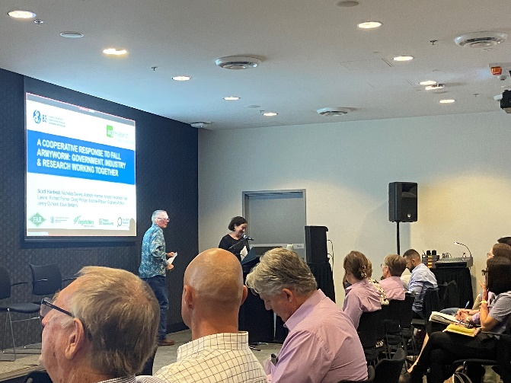
National FAW Research, Development & Extension Symposium in Brisbane, Australia.
Photo – Dr Scott Hardwick from AgResearch presenting New Zealand’s experiences with FAW.

Many thanks to Dr Heidi Parkes, Dr Melina Miles, Dr Ramesh Puri and the rest of the QLD DAF team for putting on a fantastic event and to all the participants from across Australia and SE Asia for sharing experiences and research to enable a wider collaborative discussion on the future of FAW management.

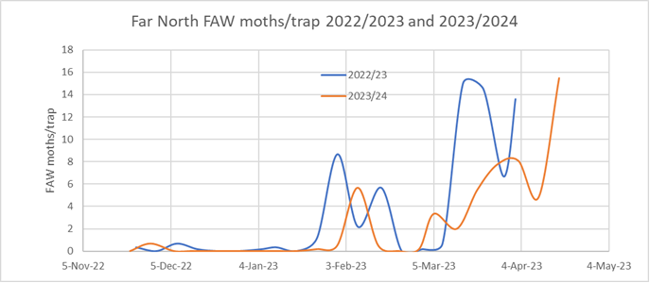
Northland moth flights – Dr Jenny Dymock has been consistently monitoring traps and scouting crops for FAR for the last couple of years, her latest report shows similarities in moth flights in the Far North over the last two seasons, but the large flights we have just experienced are later by 2-3 weeks than last year.

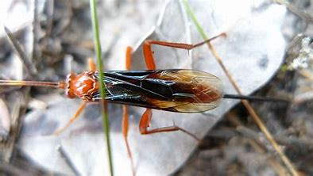
Beneficial Insects
The end of autumn and winter is a great time to plant natives that will provide refuge to these key beneficial insects that we know have been reducing FAW and other pest numbers. This Plant & Food Research podcast is extremely useful and will hopefully get you thinking about increasing the Biodiversity of your property to benefit the beneficial insects in our farming environment.
Fresh findings on beneficial insects · Plant & Food Research (plantandfood.com)

Lissopimpla excelsa
Known as the dusky-winged ichneumonid in New Zealand, has recently been observed in large numbers in Northland paddocks with multiple maize pests present. This parasitic wasp is known to target Helicoverpa armigera, does it also parasitise FAW?

What to do if you think you find fall armyworm
Photograph it: FAW can be easily mistaken for other species, so if you suspect it, take a good quality photo, and be sure to include the head, body and rear of the larvae. This can be in multiple photos if necessary. This guide from the Queensland Department of Agriculture and Fisheries outlines how to take photos of FAW.
Catch it: Samples are important for positive identification and testing.
Contact us: Contact the Foundation for Arable Research at far@far.org.nz or Biosecurity Officer Ash Mills at ashley.mills@far.org.nz
Trap network and active scouting and reporting have been fantastic throughout the season and are much appreciated.
- All data recorded (even zero finds) are valuable for the validation of modelling platforms and for understanding the pest in New Zealand.
- If you are keen to monitor a trap and share scouting information please get in touch.
- Data and observations of parasitism as well as potential relationships with other pest species would also be welcomed.

Consult the FAR website for the latest resources and identification guides
FAR Research | Welcome to the Foundation for Arable Research
Listed below are useful updates, tools and guides on detection and identification
FAR Research | Fall armyworm identification and background
FAW larval identification guide (publications.qld.gov.au)
For advice around Sparta, FAW information and requesting a great FAW glovebox guide - Fall Armyworm (corteva.co.nz) and this FAW Sparta technote Salesforce
Thresholds for economic damage
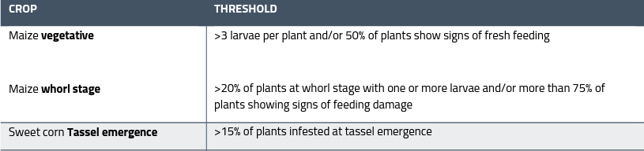
Plant Health Australia provides useful guidance for this:

Useful insight from over the ditch - https://www.planthealthaustralia.com.au/fall-armyworm/
SGRR Davis Scale Guide - 86d44eb4-7d19-5ce5-befe-4dd32eeca38c.pdf (far.org.nz)

A farm Biosecurity Register is a great way of reducing the risk of unwanted weeds, pests and diseases arriving on your doorstep. Do you have one? Find out more here FAR Research | Arable Biosecurity Risk Register

